**Hanging out our Dirty Laundry:**

**Brantford’s Soap and Washing Machine Industries**

**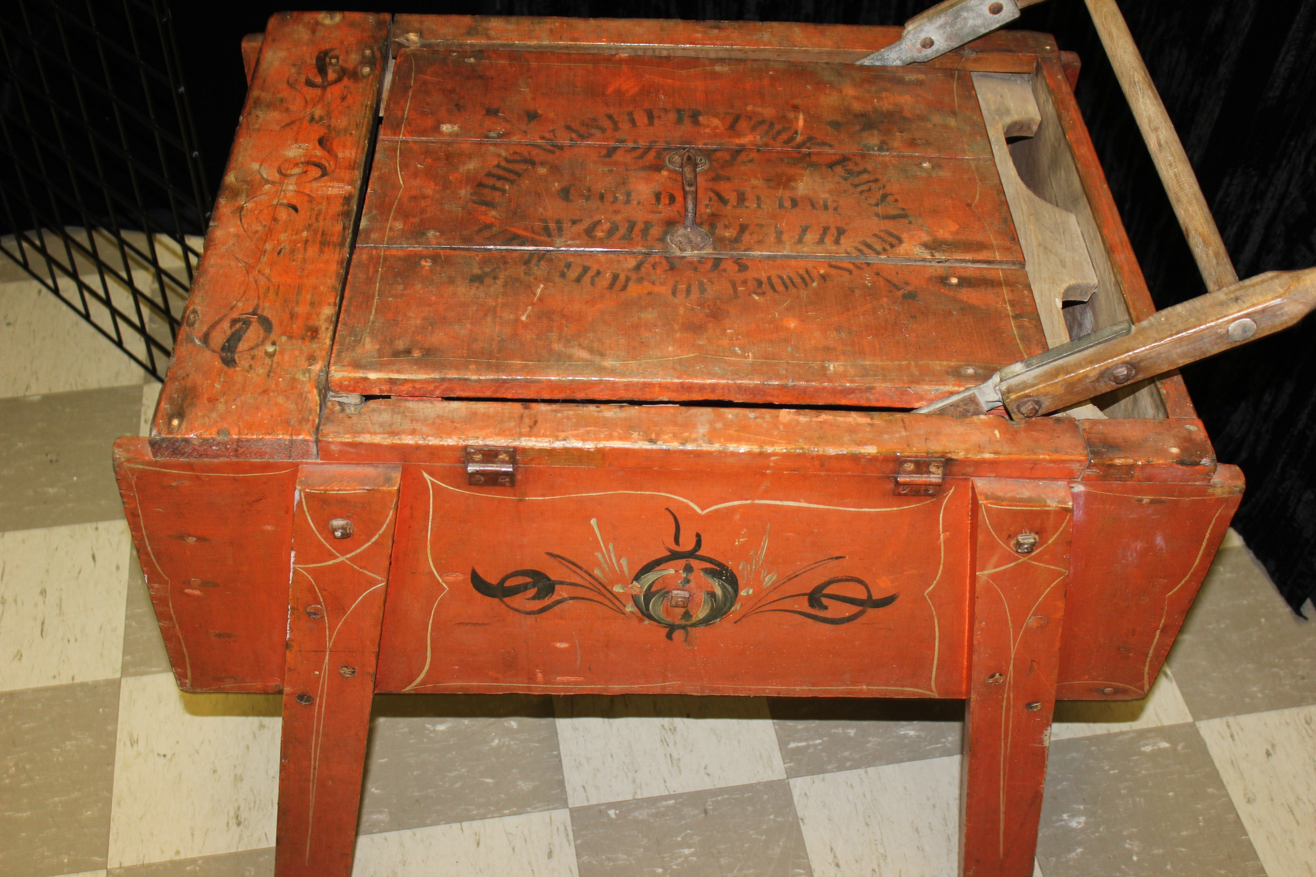**

by Nathan Etherington

for the Brant Historical Society

January 30, 2016

Table of Contents

Executive Summary3

Institutional Background4

Exhibit Title6

Big Idea6

Smaller Ideas6

Audience7

Means of Expression7

Character of the Visitor Experience8

Learning Outcomes9

Exhibit Space Dimensioned Sketch, Floorplan, and Typical Elevation11

Inspirations for the colour mood, shape, look, feel, content, layout, and overall approach to the exhibit14

Budget17

Front End Evaluation Plan19

Text for Main Introduction Panel21

Text for a Secondary Panel21

Text for Three Artifact Labels with an Image of Each Artifact22

Formative Evaluation Plan23

Summative Evaluation Plan23

References25

**Executive Summary**

*Hanging out our Dirty Laundry* is the proposed title for the next exhibition to be offered by the Brant Historical Society. Our 60-year old permanent exhibitions offer little to attract museums visits and our current temporary display has been up since February 2015. This exhibit will attempt to address these concerns and increase museum visitors during Museums Month (May 2nd to 27th).

This exhibit will invite visitors to engage with Brantford’s well-known manufacturing history by exploring its soap and washing machine manufacturers. The content of the exhibit will be focused on three companies: The Brantford Soap Works, Schultz Bros. Co. Ltd., and The Brantford Washing Machine Company. Information and artifacts will be showcased from these companies in a much more engaging way than previous exhibits have.

The exhibit will have 3 basic element designs: informational, investigational, and interactivity. The informational portions are the histories of the respective companies and will be arranged in an U-shaped arrangement along the outer walls of the exhibit room. Each wall will be dedicated to one company, provide a history of the company, highlight those involved with the company, and answer what happened to the company.

The investigational portion of the exhibit will use the centre portion of the room and act as an “Artifact Warehouse”. The warehouse will contain large pieces placed in an open concept format with minimal barriers between artifacts and visitors. It is hoped that by participants observing these artifacts up close, they will be able to postulate how some of these old washing machines would have worked.

The final component of the exhibit will be an interactive portion, which will engage various learning types and styles. One of the washing machine companies also made Crokinole boards and will engage kinesthetic learners, by asking them to read the instructions and play a game of crokinole.

From our last exhibit, participant requested seating so they could experience the exhibit. This second interactive component, the discussion corner, invites participants to sit and talk about some of the guiding questions on text panels. This will serve a dual purpose for seniors who may not be able to stand for long periods and participants who wish to engage in high-order thinking activities.

The final interactive will be a clothesline that will ask participants to “Hang their Dirty Laundry”. It is hoped that visitors will feel inspired from the entire of the exhibit experience that they will be able to postulate the next great idea to come out of Brantford or leave a comment about the exhibit.

*Hanging out our Dirty Laundry* will be an engaging exhibit, which will premier during May. There will be a museum tour occurring on the first day of the exhibit adding a great marketing opportunity for local media. This increased visibility will invite participants of Brant County to visit the museum and learn more about the proud history of our community.

**Institutional background**

Overview

Formed on May 8th, 1908, the Brant Historical Society seeks to broaden the understanding of our community and its people by exploring our heritage within the Brant area through innovative partnerships and learning opportunities thereby building a more inclusive and tolerant society. The Brant Historical Society operates the Brant Museum and Archives and Myrtleville House through which we offer the community a variety of programs and services that explore our unique heritage.

The **Brant Museum and Archives** provides an overview of the history of the County of Brant and City of Brantford and has been designated as an A-level by Canadian Museum Operating Grant. The Society has operated the museum since 1910 out of the Brantford Public Library and was relocated at 57 Charlotte Street since 1952.

The Brant Museum and Archives serves our adult education programs for various audiences on a wide range of topics. We host our **Quarterly Members Meeting** as a free event open to the public. This event includes a brief presentation from the board announcing initiatives and events followed by a guest speaker who present on topics of historical significance. We also offer a **Seniors Program** that provides an opportunity to seniors to interact with artifacts, share stories from their past, and engage in discussions about the history of our communities.

**Myrtleville House Museum**, located at 34 Myrtleville Drive is one of the oldest homesteads in Brant County and is a Heritage Canada Foundation property. The Brant Historical Society took over the daily operations of this site in 2008.

Myrtleville acts as the hub for our youth **Educational Programs**, which promote interactive learning opportunities and provide activities that help students explore their heritage. These programs are designed to fulfill expectation of the Ontario curriculum at the elementary level.

Recent Achievements

This past year, the organization has experience growth, renewal, and reorganization. We have increased our membership, volunteer hours, and revenue while finding cost savings in our operating expenses. This has occurred due to a stronger working relationship between staff and board members.

Also, we have experienced a large growth in the outreach programs that the Historical Society offers to the public. Our annual Walking Tour Series had doubled in attendance and revenue generated by this program has quintupled. Our summer camps at Myrtleville also saw a large increase in attendees with most days being sold out. Revenues from these programs also nearly doubled over the past year. Our Seniors Programs, which bring the museum to those in retirement communities also increased attendance slightly and revenues have increased by 33%.

New Initiatives

Our ongoing **Collections Management Project** continues to occur and we have added several thousand items into our inventory database. When a complete inventory is finished, we will be able to properly insure the museum to protect the value of the artifacts we possess. Another benefit is that we will be better able to share the items we have with the public. Remaining areas that need to be inventoried include half of the attic, half of the archives, and the entirety of the displays.

We are also engaging with professors and students from **Wilfred Laurier University** to assist them with our shared educational outcomes. This year, we have reached out and will offer educational opportunities to at least two courses at the University. One opportunity will allow students to come into the museum and create a small temporary exhibit with direction from staff. A second course has been interested in our *Murder, Mystery, and Mayhem* Walking Tour and over 150 students will participate in this activity.

Improving communication with members and the community has been made possible through the redevelopment of our **Brant Museum and Archives website**. While Facebook continues to engage members from outside of the organization, our website has improved how we provide communication with our members. Over the past year, we have added Board Member, Staff, Newsletter, and Board Minute Pages to the website to increase our openness to the general public. We have also continued to post upcoming events our website and have experimented with the purchase of event tickets to our website. In the coming year, we hope to continue adding new features to our website to continue our outreach to the community.

The organization has not had a strategic plan since 2013 and we are working on a new **3-year strategic plan**, highlighting 5 priorities for the Brant Historical Society. On top of this we are developing a 3-year exhibit plan to develop themes and timelines for exhibit including development, planning and design, installation, evaluation, and de-installation. This initiative will assist the museum in planning events and programming on annual basis, rather than an as needed basis with our current situation.

The Brant Historical Society currently holds over 60,000 artifacts, archives, and photographs in trust for the people of the County of Brant and Brantford. The collection is the core from which all the museum’s programs and services are based. This ensures that museum activities reflect the community and provides an opportunity for the public to interact in a more meaningful way with their history.

For information on all our programs and services, please visit our website at [www.brantmuseums.ca](http://www.brantmuseums.ca) or contact the Brant Historical Society at 519-752-2483.

**The Big Idea**

What’s the title?

* Hanging out our Dirty Laundry: Brantford’s Soap and Washing Machine Industries

What’s the Big idea? Can you put it in a single sentence?

* Brantford washing machine and soap businesses contributed to Brantford’s reputation as an innovative city and a major manufacturing hub that helped build Canada.

What’s the Exhibit all about?

* The History of the Brantford Washing Machine Company initiated by Arthur Calder Lyons who produced the Locomotive Series of Electric Washing Machines in the 1920s. The Lyons family members also have several streets named after them in the Henderson Survey.
* Eleanor Lyons recently donated an Extend Communications scrapbook to the museum. When she discovered the connection to our next exhibit, she found several additional archival documents relating to the Brantford Washing Machine Company that she donated to the Historical Society that will enhance the exhibit.
* The History of The Brantford Soap Works started by Charles Watts in 1856; By the 1880s, the company had been taken over by his son Alfred Watts who made the company into a significant global player. Alfred Watts also took over the defunct canal and used the locks to generate hydroelectric power. This resulted in Brantford factories being electrified early and transformed into the mass production system before other major manufacturing centres.
* Schultz Brothers Company started by three brothers, each taking their own specialties to build the company. Construction was the original focus of the company before diversifying into washing machines and crokinole boards. One of their washing machines won first prize in the World’s Fair in Chicago in 1893.

Why is it being created?

* A recent collection donated to the Brant Historical Society was the original inspiration for this exhibit and contained two washing machines and soap artifacts. Other additional donations ensure that we have enough for an exhibition on this theme.
* This will be the main exhibit for Museums Month in May of 2016 and provide participants participating in the Museum Tour an extra special exhibit.

What will it achieve?

* Enable us to fulfill out mandate and our goal to produce out 3 exhibits a year in the museum facility.
* Provide the opportunity for the creation of a new education program to provide revenue.
* Generate a significant increase in museum attendance for Museums Month in May.

Why should a visitor come to see it?

* To re-engage with Brantford’s industrial history.
* To learning about revolutions in the mashing machine industry and the soap industry.
* To feel inspired and create innovative ideas for new industries in Brantford.

**Audiences**

What is the Primary Audiences for which the exhibit is intended?

* Young Adults to Seniors

What are the characteristics of that audience and how will the exhibit address them?

* Visual
* Critical Thinkers
* Discussion Based Interactions
* Interactive Portion

Addressing the audience through:

* Washing Machines will be in an open-concept themed area with their tops off so that you can visually inspect and conceptualize how the machine would have operated.
* Pose questions that engage participants to be part of an interaction discussion about innovations in industry in Brantford.

Are they secondary audiences?

* Children aged 4-16

What are the characteristics of those audiences?

* Schools for Education Programming
* Time limited
* Short attention span

**Means of Expression**

What is the range and nature of the artifacts that will be used?

* There will be five large (greater than 3 feet in the largest dimensions), heavy objects that will located in the centre of the room in an open-concept arrangement.
* There will be the opportunity for several small to mid-sized objects (less than 2 feet in largest dimension) interspersed with photos and text panels giving the visitor information. These smaller artifacts will be displayed in cases in front of wire racking.

Will the exhibit include interactives?

* Will include 2 croquinole boards – one that is an artifact, the other can be played during the exhibit. With traditional instructions to guide users.
* The Discussion Area will allow visitors an opportunity to discuss their ideas or reflect on their exhibit experience.
* Interactive leave a comment idea that allows people to propose the next innovative idea to come out of Brantford or leave a general comment about the exhibit.

Will the exhibit include audio?

* No

Will the exhibit include video?

* No

Will the exhibit include other elements?

* Track lighting exists in the exhibit space. Once the exhibit is installed, this lighting will be manipulated to provide adequate lighting in the room.

**Visitor Experience**

What will the exhibit feel like to visit?

* The exhibit should immerse the visitor into a warehouse-like gallery. Visitors should be guided through their experience with the use of visual cues provided by the intro panel and taped arrows on the floor. By visiting and interacting with the exhibit, visitors should feel inspired by seeing the innovation in the artifacts from the past to propose the next great idea to come out of Brantford.

What are the mood, theme, and structure of the exhibit experiences?

* There are three spatially-organized elements that will bring the exhibit together:
  + Artifact Warehouse – a central warehouse layout with minimal barriers to artifacts
  + Small objects and information panels – attached to metal framing and cases arranged in an U-shaped arrangement around the Artifact Warehouse
  + Interactive areas include a crokinole board, discussion area, and leave a comment clothesline

What will audience(s) see and do in the exhibit?

* See large washing machines and crokinole board (artifact) and reflect on “How did this machine work”?
* Play a game of crokinole with rules provided (modern board)
* View information panels and smaller objects showcasing 3 companies: Watts Soap Works (Brantford Soap Works), The Brantford Washing Machine Company, and Schultz Brothers.
* Flip Through Extend Communication Scrapbook (same owner as Brantford Washing Machine Company)
* View pictures and archival materials about the Brantford Washing Machine Company, including patents for the design of washing machines and wringers
* See historic ads for each company / Brantford Soap Company Letterhead
* Two Large Framed Ivory Soap Ads from Brantford Soap Works
* Sit in the discussion corner and reflect on the exhibition
* Leave comment on laundry-themed papers on clothesline, asking them to leave a comment about the exhibit OR What the next big innovative idea to come out of Brantford?

What is the expectation for the average length of stay?

* 15-30 minutes for families with children
* 45-60 minutes for adults
* 90 minutes for education program

**Learning Outcomes**

What is the expectation for the knowledge and understanding that visitors will bring to the exhibit?

* Brantford has an industrial heritage where any type of machine could have been made in Brantford.

What is the expectation for what knowledge and understanding that visitors will take away from the exhibit?

* Brantford has a long history of manufacturing washing machines
* Civic Pride in Brantford’s industrial heritage
* Companies in Brantford often produced many products not implied by their name

How will this be measured?

* Comments left on the clothesline.
* Online tickets will be purchased and be required to provide an email address. A short questionnaire will be sent out after the exhibit end date of May 27th.
* Comments received by employees, board members, and volunteers directed to staff.
* Shouts of excitement from the exhibit (i.e. from figuring out how something worked or from interactive elements)

General Design Concept

Elements

* Large Banner-Style text panel hanging above large object area saying the name of the exhibit or “Artifact Warehouse”
* Around each large object use colored floor tape to act as a foot barrier, allowing minimal “breathing room” between participant and artifact.
* Colored tape on floor to guide participants around the exhibit room.
* Wire racking to display framed photos and information panels hung with S-hooks.
* Modern Crokinole Board next to “Artifact Warehouse” with large text panel explaining rules and scoring so visitors can play a game.
* 2 Clotheslines (Adult height and child height) mounted to wall with clothespins.
* Laundry themed paper pieces preferably different sizes with different images (example: bedsheet, bath towel, sweater, pants, etc.).
* Large artifact text panels will be 32” h x 23” w mounted on washboard like stands made by Chris Greenlaw (see Figure 1)
* The interactive crokinole board be placed on a washing stand built by Chris Greenlaw (See Figure 2)
* Crokinole Boards in the Museum Gift Shop?

Community Resources and Volunteers

* Making and Installation of the Clothesline Interactive (Chris Greenlaw)
* Recruit community member (someone not already within the organization) to serve on exhibit committee.
* Volunteers to do research on the history of companies or explore interesting tidbits.
* Volunteers to assist when education programs are booked.

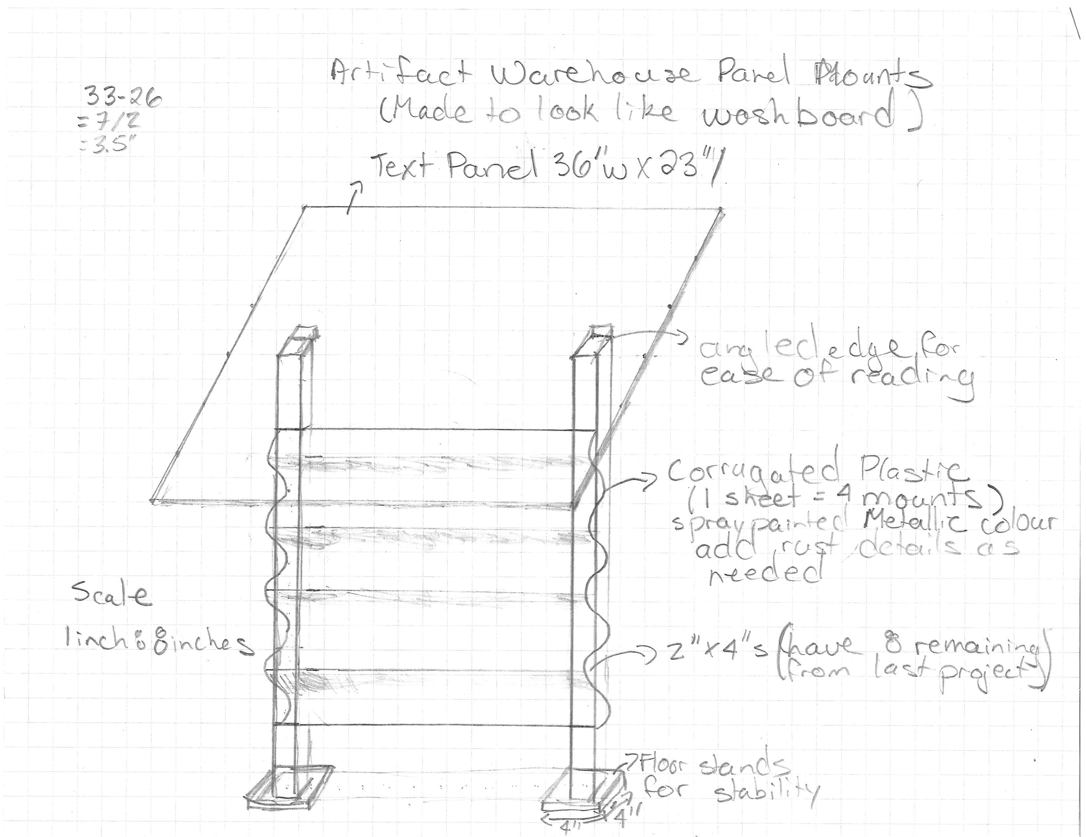

Figure – Washboard stand measurements for large artifact text panels.

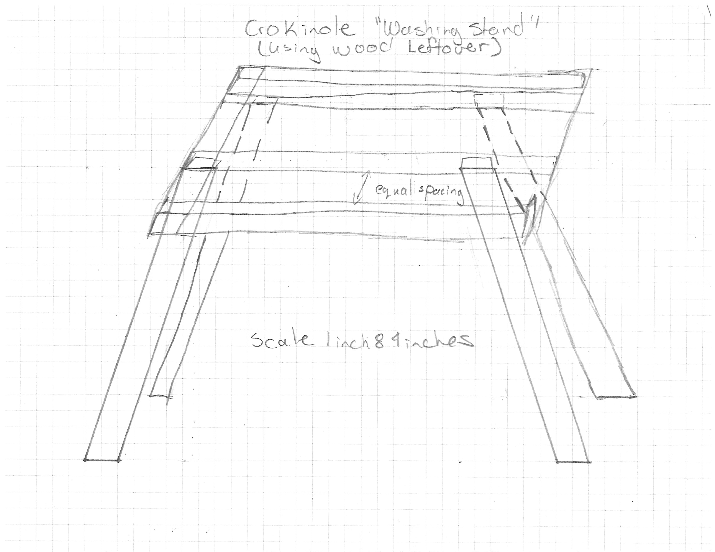

Figure - Washing stand measurements for stand to hold interactive crokinole board.

**Exhibit Space Dimensioned Sketch, Floor Plan, and Typical Elevation**

Exhibit Dimensioned Space (Preliminary)

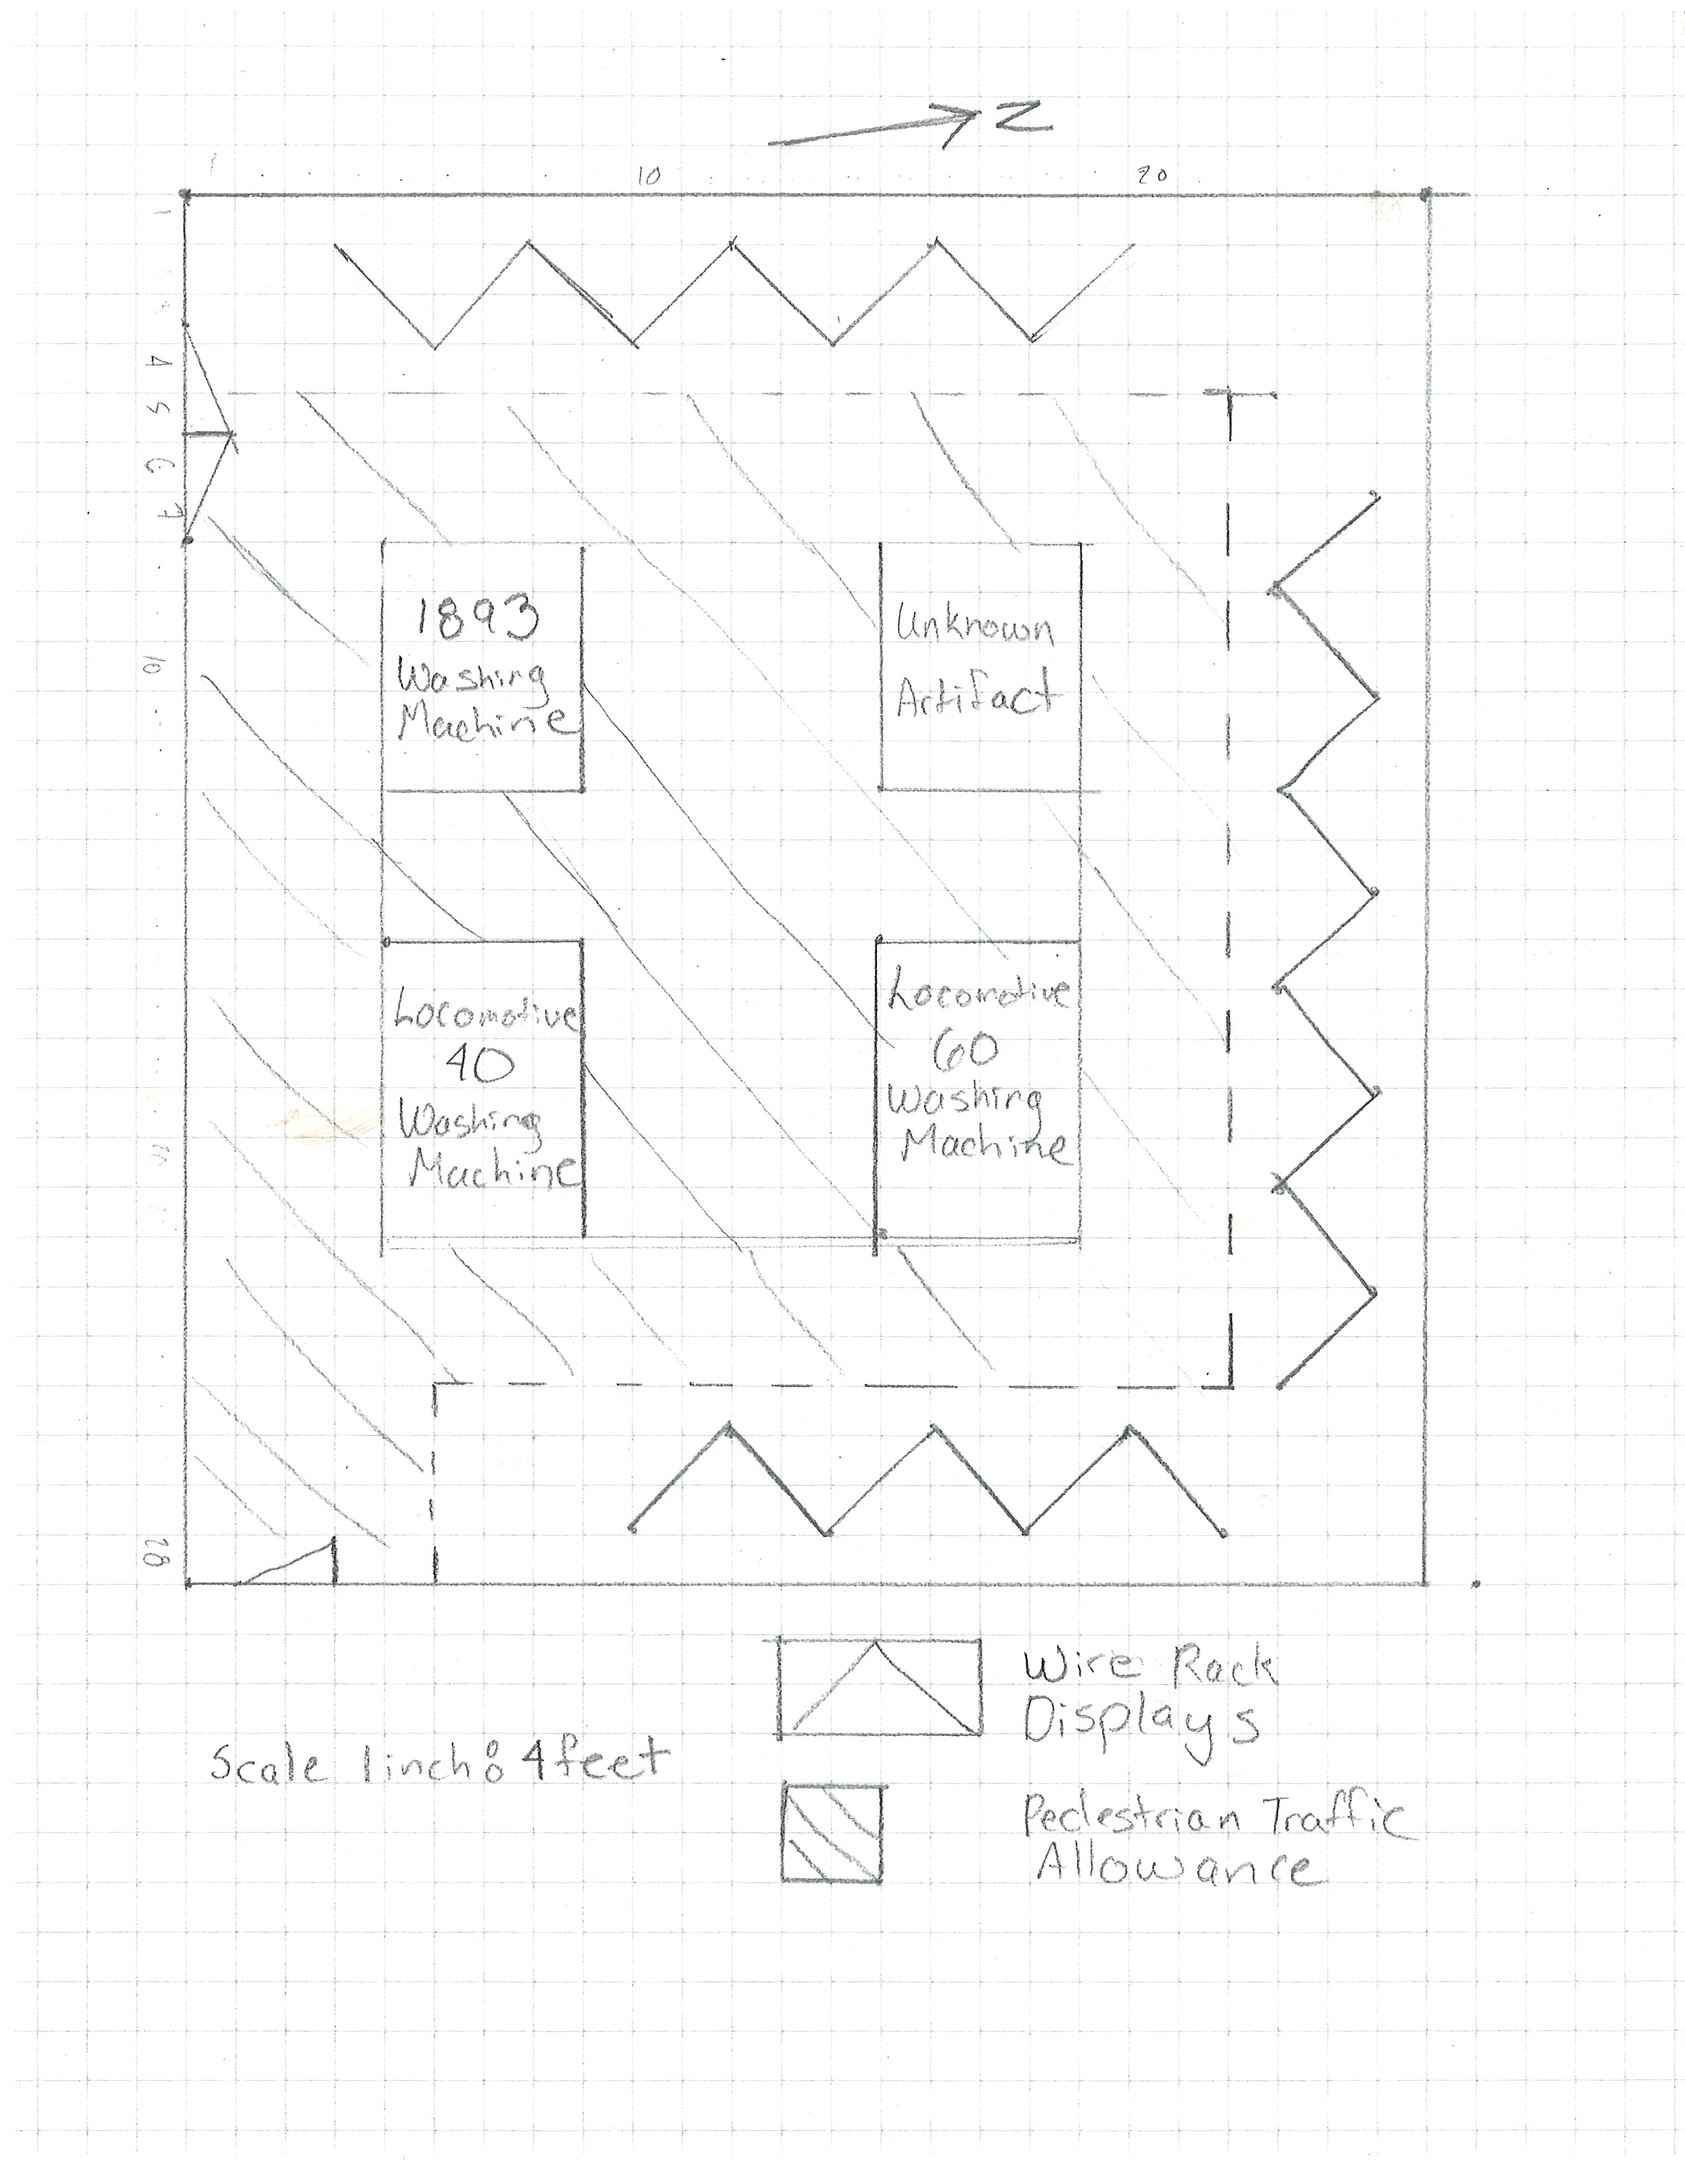

Figure 3 - First Draft of the exhibit space dimensioned sketch. Many of the elements are similar to the final design.

Exhibit Space Dimensioned Sketch (Final)

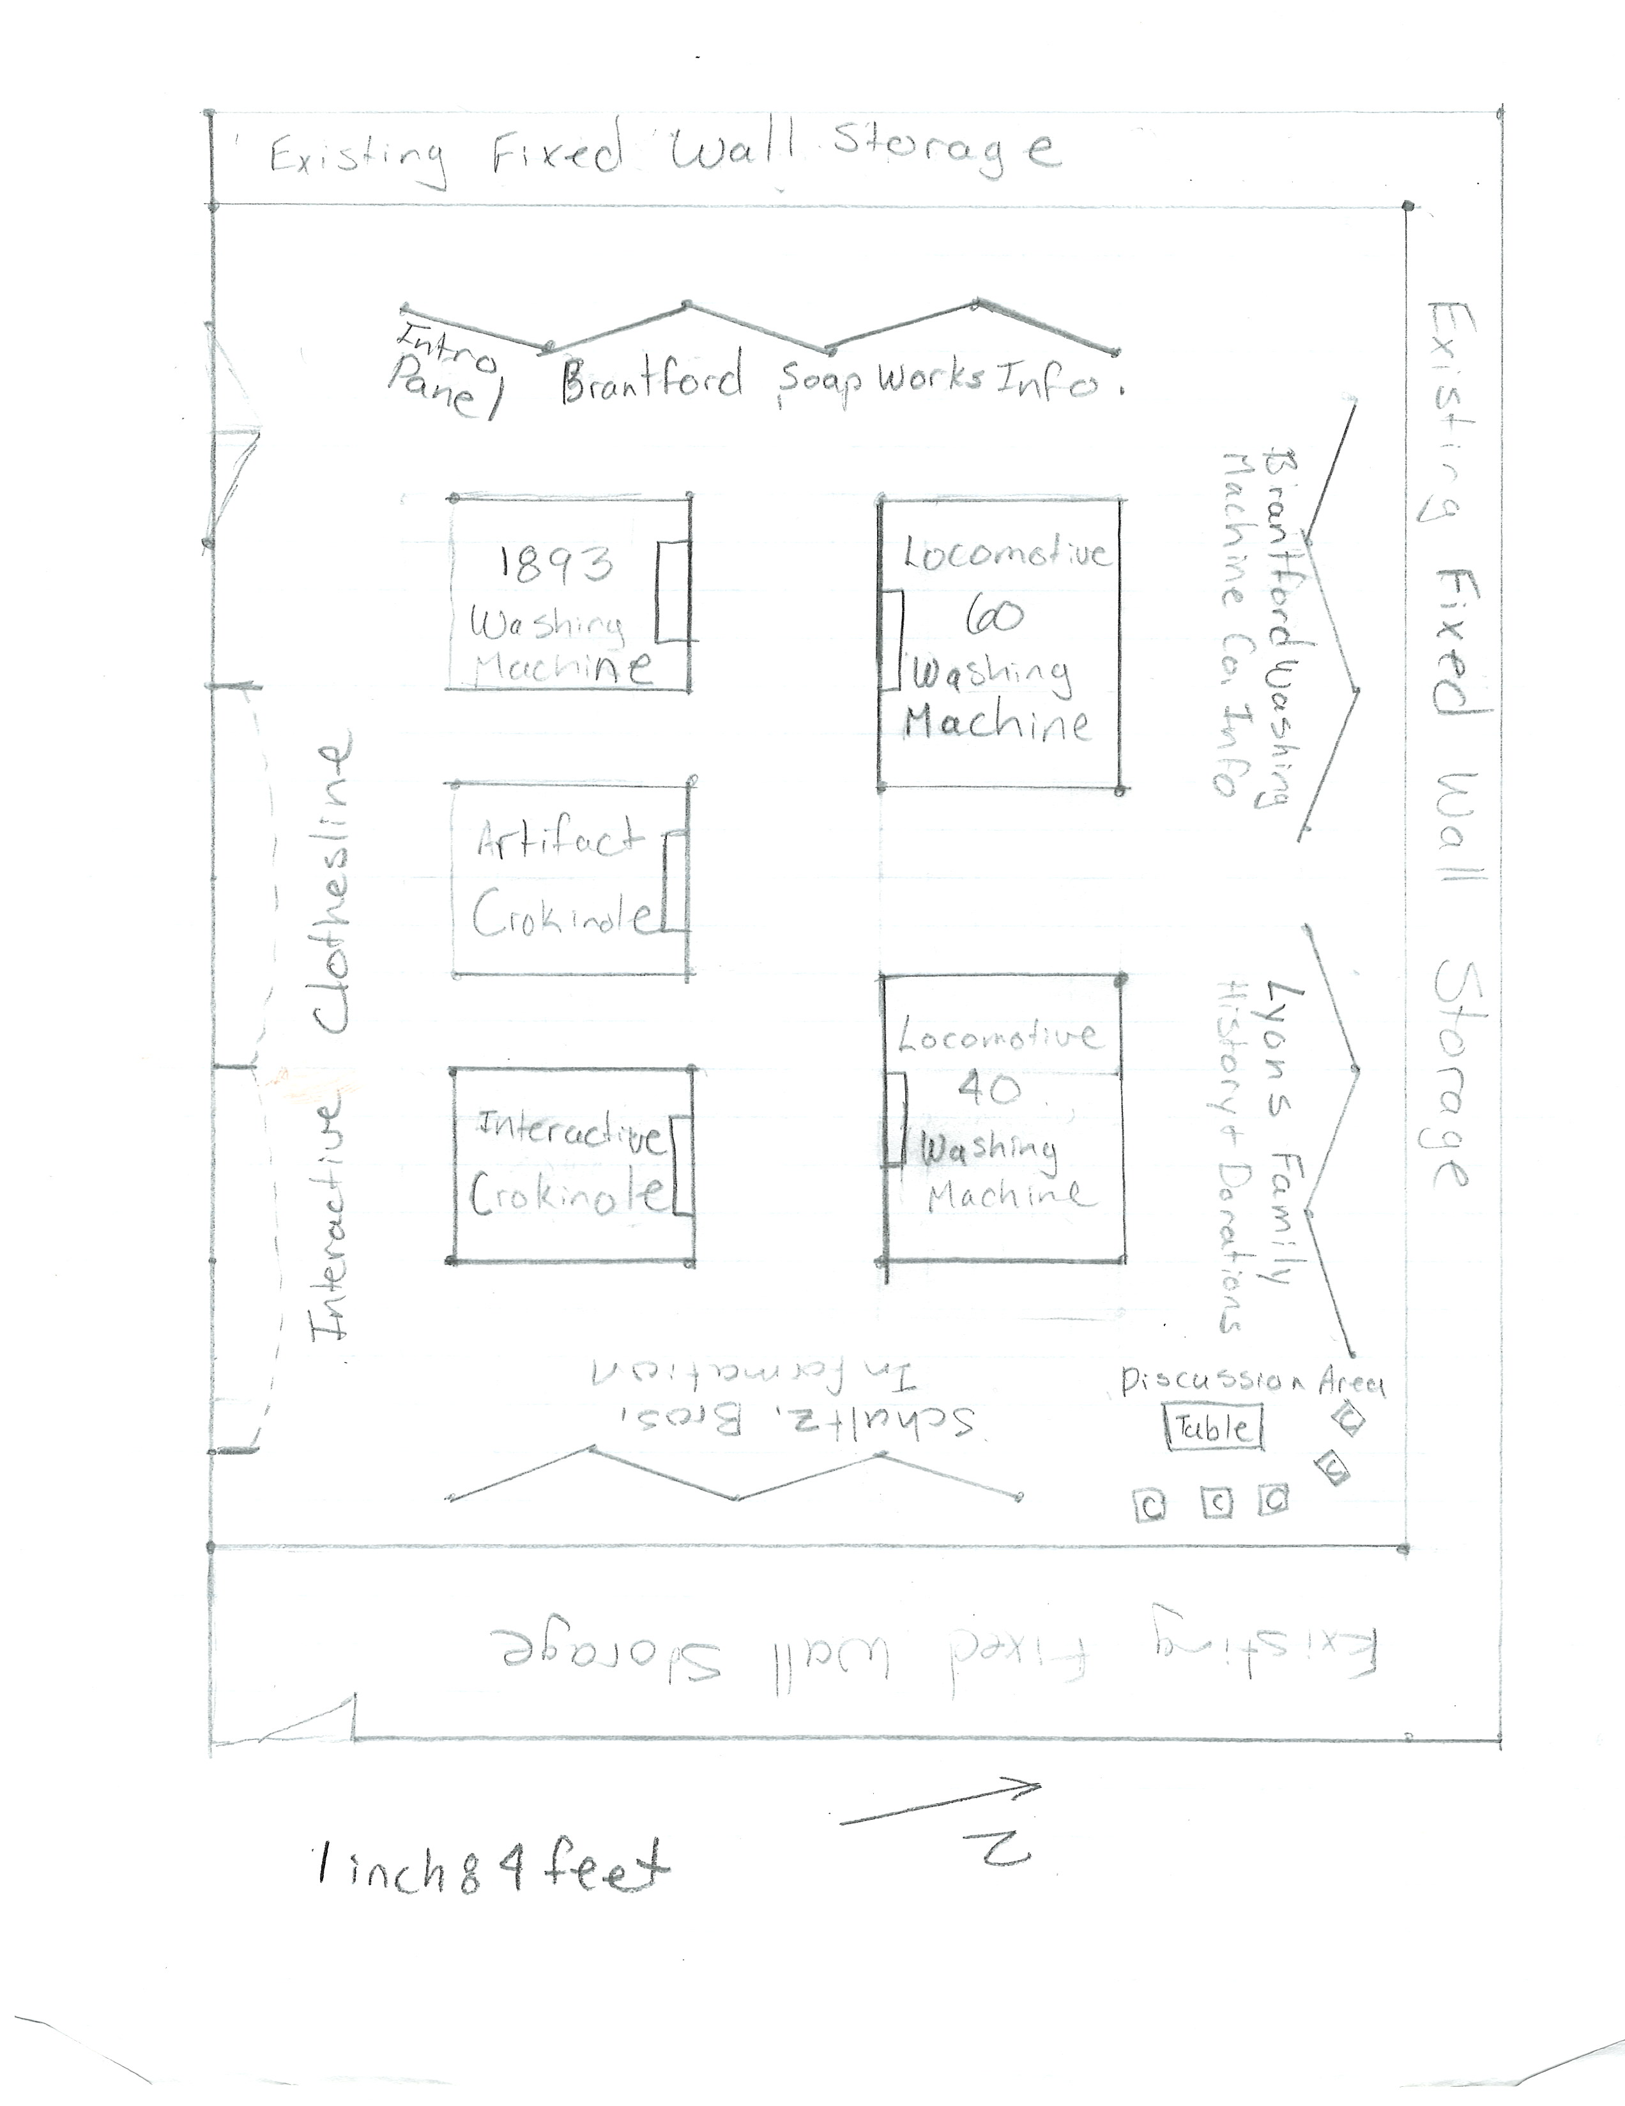

Figure 4 - Finalized Exhibit Space Dimensioned Sketch. The “Artifact Warehouse” has been rearranged. The wire racking has been shifted southwards on the east wall to allow for the creation of the Discussion Area.

Typical Elevation (Sketch)

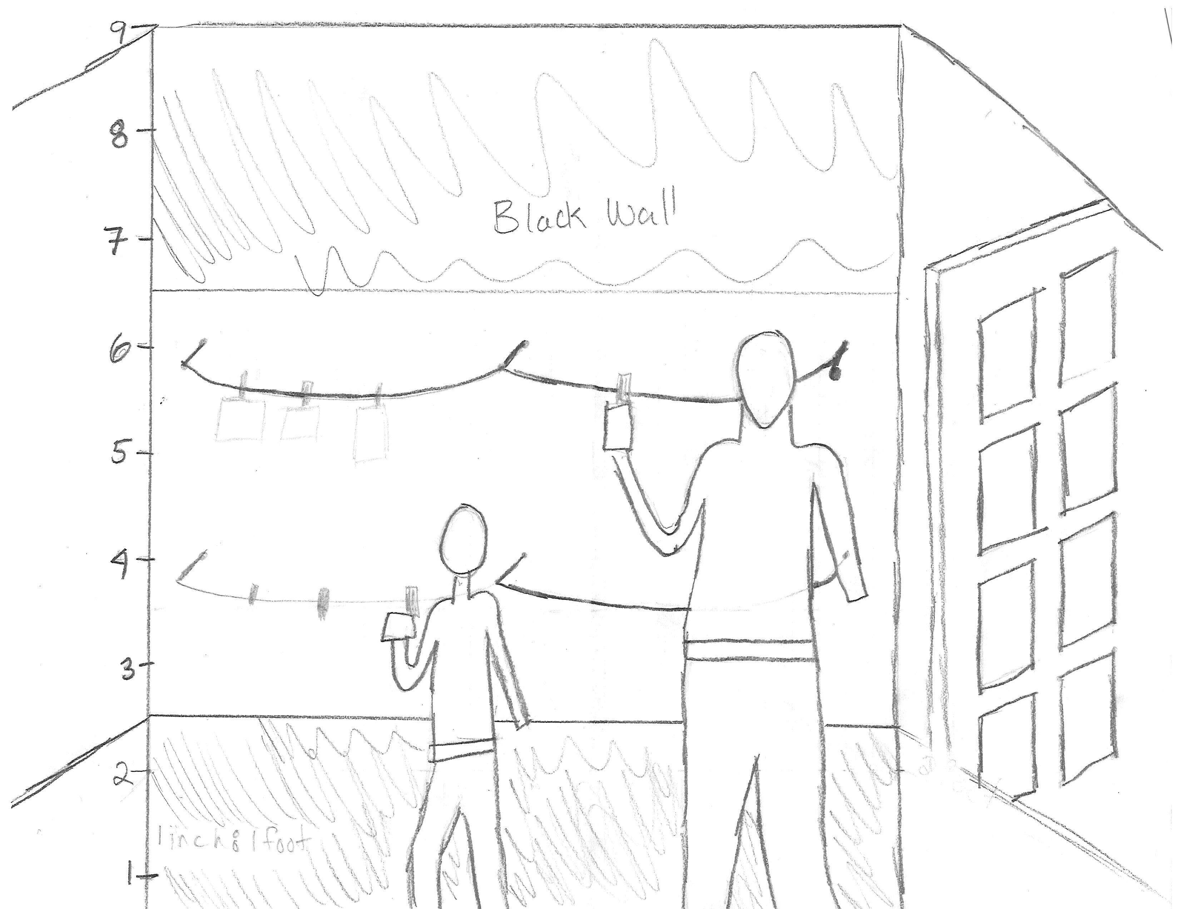

Figure 5 - Typical Elevation of Interactive Wall. Child is 4’ 5” in height (approximately 8 – 10 years in age). Poorly proportioned adult is height of 6’3”. Horizontal lines outline the white center panel and the scribbled areas represent the black wall. On the right side is the door with allowance.

**Inspirations for the Exhibition**

The artifacts and their size set up the inspiration for the layout and mood of the exhibit. As most of the artifacts are large and take up a sizeable portion of the exhibit, the decision was made to give an industrial design to the feel of the exhibit. These large washing machines and other artifacts will be places in the centre of an open concept room giving the feeling of a warehouse. Many of these artifacts are showing in Figure 6.

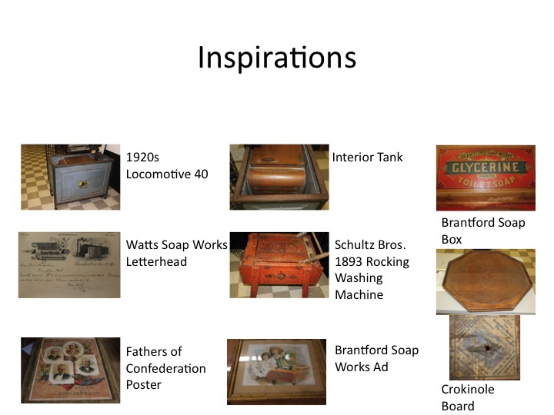

Figure 6 – Figure of Artifacts that act as the Inspirations. Most of these artifacts were a recent donation to the Brant Historical Society. Crokinole Board was made by Schultz Brothers are well. Label on bottom of crokinole board denotes the company, the products they produce, and their location.

These large pieces will be outlined with the use of colored floor tape to outline and guide visitors around the exhibit. This tape will act like the old “velvet rope barrier”, by providing a caution to visitors to be careful in this close proximity to the artifacts. The tape will also outline the U-shaped informational area and be used to make arrows to guide visitors around the exhibition.

The smaller pieces, like posters, letterhead, and the glycerine box (See Figure 6) will be displayed with the information panels. These should be in appropriately sized display cases. These will be arranged in a U-shape around the room. A recent donor also reached out and donated several archival documents from the Lyons family archive relating to the owners of the Brantford Washing Machine Company. This material will be used to enhance the information panels.

In order to visualize how the exhibit would look, we spent an hour setting up the exhibit space as if the exhibit were occurring. We took photos of this process and made panoramic views from two locations: the door at the entry way to the exhibit and the discussion area outlined on the layout (Figures 7 & 8 respectively).

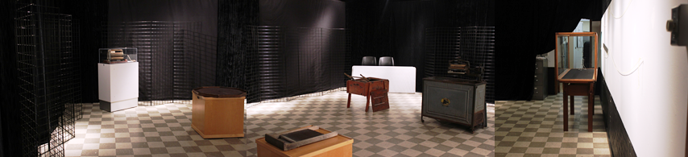

Figure 7 - Panorama of exhibit room. The left side of the photo is the west wall that pans through the north and east wall before ending on the right side of the picture with the south wall. From this view, you can identify the U-shaped wire rack stands that will hold the information panels with small artifacts in front. In the centre is the “Artifact Warehouse” that will hold large objects. The far corner of the room shows tables and chairs indicating the discussion corner. The large display case on the right side of the photo will be removed for the exhibit.

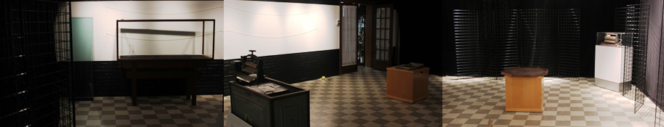

Figure 8 - Panorama of the exhibit room from the discussion corner. The left side of the photo is showing the east wall panning through the south and west walls before ending on the right side of the picture with the north wall. Along the south wall in the white strip are two yellow lines to represent the child and adult clotheslines.

This process of setting up the mock exhibit allowed us to contextualize what it would be like in the space. When we finished the mock up and looked at the layout, we discovered that our original layout would have to be slight modified and shifted (See Figures 3 & 4). This would allow for optimizing the use of the exhibit space by modifying the placement between large artifacts and better pedestrian flow with the space. This also allowed for the addition of the discussion area, a recommendation for seating from a previous exhibit. Finally, this process also finalized where each of the informational panels would be located for each of the companies.

The potential colors that we wanted to use for the exhibit ate displayed in the table below (Figure 9). After consultation about which colors would work with the exhibit, we chose Pantone Process Black C as this is the existing wall and curtain color as one of our colors. Many of the intended colors taken from pictures of the artifacts ended up not working together or becoming difficult to read. The two accent colors that were chosen were Pantone 5477C and Pantone 471C. These three colors will incorporated into the text panels for the exhibit.

|  |  |  |  |
| --- | --- | --- | --- |
| Pantone 730 C  #ab6c39  R: 171  G: 108  B: 57 | Pantone 877 C  #8e644b  R: 142  G: 100  B: 75 | Pantone 430 C  #9195a1  R: 145  G: 149  B: 161 | Pantone 471 C  #d96b38  R: 217  G: 107  B: 56 |
| Pantone Process Black C  #030303  R: 3  G: 3  B: 3 | Pantone 484 C  #a62c17  R: 166  G: 44  B: 23 | Pantone 5477 C  #44554b  R: 68  G: 85  B: 75 | Pantone 479 C  #a17f64  R: 161  G: 127  B: 100 |

Figure - Taken from the wooden artifacts from the exhibit, these were out 8 potential colours. Many conflcited with each other and as a result we were left with Pantone 5477 C, Pantone 471 C, and Pantone Process Black C.

**Budget**

The organization’s exhibit budget for the year is approximately $4,000. Therefore, for the scale of the exhibit, we hope to use a minimal budget to take up half of the annual budget. The $2,000 anticipated cost of the exhibit is outlined in the chart below:

|  |  |  |
| --- | --- | --- |
| Expenses | | |
| Item | Estimated Cost | Additional comments |
| Design costs | $255 | Materials for clothesline, rope for clotheslines, 4 wooden wash board panel mounts, 1 washstand, and floor tape. We have eight 2x4s remaining that we will use to minimize these costs. |
| Research and Curatorial | $0 | In-kind use of permanent staff to do research related to Exhibit |
| Graphics and Mounting | $400 | Mounting on Gatorboard would use most of the exhibit funds; Use Foamcore to save funds. Quote provided by TMP Printing, |
| Interactives | $200 | Purchase modern crokinole board for guests to play, paper resources for the clothesline |
| Marketing and Promotions | $500 | Includes cost of our 3rd party resource @ $85/hour for 5 hours; $75 worth of printing costs |
| Opening Reception | $400 | Food and wine costs |
| Subtotal | $1755 |  |
| 14% Contigency | $245 |  |
| Total Exhibit cost | $2000 |  |
|  |  |  |
| Revenue | | |
| Item | Estimated Income | Additional Comments |
| Senior Admissions | $400 | Estimated attendance of 80 seniors @ $5 |
| General Admissions | $800 | Estimated attendance of 100 @$8 |
| School Group Admissions | $750 | Estimated 5 school groups @ $150/visit |
| Total Expected Income | $1950 |  |

The design costs associated with this exhibit is intended to be minimal. The floor tape costs is about $5, we have existing wood that may be use in constructing wooden floor mounts. Costs of doing research and curatorial costs will be assumed by the organization as part of its annual operating budget. When looking at the cost of two 8’ x 4’ sheets of Gatorboard would overtake the exhibit costs so many other elements would not be achievable. Foamcore is a quarter of the cost and will be used to save the budget. The only interactive costs include the custom paper design as a member donated the use of his crokinole board for the exhibit.

Our 3rd party graphic design firm will be responsible for laying out the information panels for the exhibit and creating a flyer to be used to advertise the exhibit. The marketing and promotions budget includes hourly rate of the service and printing costs for the flyer.

In the past, opening receptions have ranged between $300 and $1000. We aim for a modest exhibit launch of $400 on food. There is the potential to ask Extend Communication to be our gala sponsor and their logo will be printed on gala invites. We have wine left over from the last exhibit so that we will not have to purchase more. With a 14% contingency fund for the exhibit, the total costs of the exhibit should be $1,995.

The direction from the Board of Directors suggests that our exhibits should be revenue-neutral, as we learned from our last large exhibit where we lost about $1,000. While it is more important to fulfill our mandate, we should attempt to weigh both concerns adequately. Based on our latest big exhibit, the Lawren Harris Exhibit, we had around 200 visitors for a 2 week period with guests paying a $20 general admission.

This exhibit is not expected be as big of a draw as the Lawren Harris Exhibit, has a smaller overall budget, and guests will be paying less, we believe the proposed fee structure is reasonable and competitive. Our attendance numbers attempt to be on the conservative side for general admissions and an increase in the number of school visits.

In monetary terms this exhibit we anticipate 3 different revenue streams to aid in our revenue-netural design. Seniors in the community makes up one of our target audiences, generating $400 in admissions. The other portion of our main audience is general admission generating $800. During certain times we could offer educational programming to local schools generating $750. In total we estimate total revenues of $1950, which is close to being revenue neutral. We attempted to make a model that would incorporate various price points and attendance options. However, without good metrics from previous exhibits, we were not able to produce a stable and reliable model. The summative evaluation should assess these estimates so that more reliable numbers can be used in the future exhibits to predict revenue generations.

**Front End Evaluation Plan**

Our front-end evaluation plan aims to seek feedback from stakeholders about their expectations for the exhibit. We have opted to do a survey as a low cost and low time commitment way of attempting to solicit feedback from a number of individuals. A blank example of this form is located on the next page in Figure 10.

The survey assesses a number of factors such as cost, promotions, and the content of the exhibit. The Family Learning Forum highlights factors one might consider including in their front end evaluation plan (U.S. Department of Education, 2012). Our front-end evaluation falls within these guidelines.

From feedback received thus far, our estimated revenues appear appropriate. Some of those surveyed thought that a neat interactive option would be to make your own soap bar. After some research it was thought this would be an additional and unnecessary expense and would be a messy process to implement. The content seems to be self-explanatory to most respondents, however the crokinole board is such a beautiful artifact not to show as part of the exhibition. Those surveyed suggested several new places to advertise at low cost to the organization. Once we have reviewed these sources, a new marketing plan will be drawn up to apply to the next exhibit.

As previously noted above, setting up a mock exhibit was a valuable tool in reassessing the presentation of the exhibit. The layout of the exhibited could be changed slightly to give a better style of presentation and traffic flow. This can be seen with the changes shown from Figure 3 to Figure 4. It is recommended that in the future, if possible, a mock set up of the exhibit should been done either before installation to see if the layout should be modified. This could be done before when the room is empty before installation or in a large storage area approximately the same size as the exhibit.

**Front-End Evaluation**

Proposed Exhibit Title: Hanging out our Dirty Laundry

Big Idea for the Exhibit: Brantford Washing Machine and Soap Businesses contributed to Brantford’s reputation as an innovative city and a major manufacturing hub that helping building Canada.

From the information provided above, please tell us your opinion on the following:

1. What artifacts do you think should be included in this exhibit?
2. What information do you think should be included in this exhibit?
3. Do you think there should be interactive materials included in this exhibit? If so, what specific interactive activities should there be?
4. What should not be included in this exhibit?
5. Where should we post information and promotional materials for this exhibit?
6. What would you expect to pay to see this exhibit if you were …
   1. A Member? $\_\_\_\_\_\_\_\_\_\_\_\_\_\_\_\_\_\_\_\_\_\_\_\_\_\_\_\_
   2. A Senior? $\_\_\_\_\_\_\_\_\_\_\_\_\_\_\_\_\_\_\_\_\_\_\_\_\_\_\_\_
   3. A General Admission? $\_\_\_\_\_\_\_\_\_\_\_\_\_\_\_\_\_\_\_\_\_\_\_\_\_\_\_\_
   4. A School Group? $\_\_\_\_\_\_\_\_\_\_\_\_\_\_\_\_\_\_\_\_\_\_\_\_\_\_\_\_

Figure 10 - Example of Blank Front End Evaluation for Hanging out our Dirty Laundry Exhibit.Text for Main Introduction Panel

Brantford citizens have long been known to take pride in the manufacturing history of our city. *Hanging out our Dirty Laundry* aims to engage with this history by exploring Brantford’s Soap and Washing Machine industries.

Explore the informational panels around the room that outline the history of the local companies The Brantford Soap Works, Schultz Brothers Co. Ltd., and The Brantford Washing Machine Co. Ltd. All these businesses achieved national recognition for the products that they offered.

Observe examples of these washing machines in the Exhibit Warehouse. When were these artifacts made? How did they work? What innovative ideas were included in their design?

Sit, reflect, and discussion these questions in our Discussion Corner. Think about the next great idea to come out of Brantford, or maybe leave a comment about the exhibit. Write this out on a piece of “laundry” and hang out your dirty laundry with us.

**Text for Secondary Panel**

The Brantford Soap Works was founded by Charles Watts in 1856 and was located on Spring Street. In 1868, his son, Alfred Watts bought his father out and renamed the company A. Watts & Co.

One day in 1862, Robert Henry walked into Charles Watts dry good store and he started working at the soap works. He became a partner with Alfred when he took over the company and managed the day-to-day operations. On top of managing the Soap Works, Robert Henry was also elected mayor of Brantford in 1878 and 1879 overseeing the construction of the first Lorne Bridge connecting Brantford to West Brant.

By the 1880s, the business had grown so much that is employed 15 men, used 16,000 pounds of tallow a week, and produced 14 varieties of soap. It should not be surprising that they also made laundry soap.

Soaps from this factory reached all over Canada including the North-West Territories. They produced $500,000 worth of goods in 1883 or an estimated $11 million industry in modern dollars.

**Text for Three Artifact Labels with an image of Each Artifact**

|  |  |
| --- | --- |
| Exhibit Label | Picture |
| 977.211.1  Crokinole Board  Manufactured by: Schultz Bros.  Material: Wood  Date: c. 1940 | IMG_3346.JPG |
| 2016.1.6  Locomotive 40 Electric Washing Machine  Manufactured by: The Brantford Washing Machine Co. Ltd.  Materials: Steel, Ceramic, and Tin  Date: c. 1924 | IMG_3335.JPG |
| 2016.1.5  Wooden Rocker Washing Machine  Manufactured by: Schultz Bros.  Materials: Wood and Steel  Date: March 18, 1892 | IMG_3337.JPG |

**Formative Evaluation Plan**

The formative assessment timeline will take place during the “soft launch” period of this exhibit, from the start of May to the end of the gala on Thursday (May 2nd-5th). During this period, we will ask participants to fill out a brief survey while they are visiting the exhibit.

As our main target audience is mostly for adults, we want to use a formative assessment tool that is intended for adults. According to The Office of Vocational and Adult Education (2011), these assessment tools should include identifying the gap, feedback, learning progressions, and student involvement. In our case, “students” will be interpreted as “museum visitors” and their experience with our exhibit.

Our assessment will address the first three through a simple 3-2-1 card that attempts to assess the visitor experience, the fourth missing element. We will ask them 3 things they liked about the exhibit, 2 things that they learned in the exhibit, and 1 thing that we could improve for future exhibits. The tool will also maximize the feedback we receive from guests as the survey is short and easy to complete.

**Summative Evaluation Plan**

Our approach to the summative evaluation plan will be to assess those who visit the exhibit after our gala event on May 5th. We hope to have a two-pronged approach to our assessment to maximize the amount of feedback that we receive, so we are able to improve on future exhibitions with the expectations of our visitors.

To assist with the summative plan, we used a backwards design approach in developing our evaluative tool. The first step in the backwards design approach asks “What information do we want assess from our guests?” Once we have answered that question, we will design our evaluation to obtain data we wish to get (Association for Supervision and Curriculum Development, 1998). In this exhibit, we want to find out if there is anything we can do to improve our visitor experience and therefore our guest counts for exhibits in the future. If we are able to increase our museum visits and provide a revenue neutral exhibit, our next goal would be to produce a profitable exhibit.

In the first prong of this approach, we will collect e-mail addresses from those who purchase tickets online and in person. After the exhibit closes, we will address respondents through an online survey that should take no longer than 5 minutes complete. This survey will take into account basic demographics (age, sex, make up of the group they attended with, and education level.

The next section of the survey will attempt to obtain information and feedback about the exhibition itself using a table and 5 options (too high, high, what I expected, low and too low). Questions asked of respondents will ask them to reflect on topics such as a) the price of admission, b) the educational value of the exhibit, c) the ease of flow of the exhibit, d) the amount of artifacts in the exhibit, and e) the amount of interactives in the exhibit.

The final section will be a text field to allow attendees to give any further feedback and ask respondents to enter their email if they would like to take place in a 30-minute focus group about the exhibit.

In the focus group, we reflect the questions above and look for more elaborate answers. For example, when asking about the price of the exhibit, we would prompt with “What do you think the price for the exhibit should have been? ”. Results from both the online survey and focus group will be compiled into a report and provided to the staff and board. Included in the report will be an action plan to address concerns raised by visitors that will be incorporated into the following exhibit planning process.

**References**

1. U.S. Department of Education, Office of Vocational and Adult Education. (2011). J*ust Write! Guide*. Washington, DC: Author. Available online from <https://teal.ed.gov/tealguide/formativeassessment>.
2. Association for Supervision and Curriculum Development. (1998). *Understanding by Design*. Alexandria, VA: Author. Available online from <https://www.fitnyc.edu/files/pdfs/Backward_design.pdf>